My code has the following error:
expected ';' after expression
controlflow_ifstatements.cpp 16:17
std::cout<< "slowdown" \n "windscreen on" << std::endl;
PM
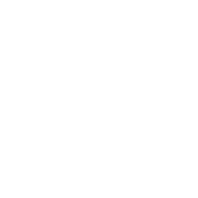
Assistant
1 year ago
Debug
The error "expected ';' after expression" in the code snippet std::cout<< "slowdown" \n "windscreen on" << std::endl; arises because you are trying to concatenate strings using the \n operator, which is not a valid way to do so in C++. The \n is used for newline characters, not string concatenation.
Here's the corrected code snippet:
std::cout << "slowdown\nwindscreen on" << std::endl;
Explanation:
- String Concatenation: In C++, you concatenate strings using the + operator. However, it's more common and efficient to use the << operator for outputting strings.
- \n for Newline: The \n is an escape sequence used to insert a newline character, creating a line break in the output.
- std::endl for Flushing: The std::endl manipulates the output stream, adding a newline character and flushing the output buffer. It ensures that the output is immediately visible, even if the buffer is not full.
This corrected code will print the following output:
slowdown
windscreen on

